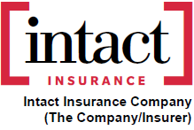
AB-S.E.F. No. 92
LIMITATION TO HIRED AUTOMOBILES AND
AUTOMOBILES OPERATED UNDER CONTRACT ENDORSEMENT
(For attachment only to a Non-Owned Automobile Insurance Policy S.P.F. No. 6)
In consideration of the reduced premium as set out in the Policy or in the Certificate of Automobile Insurance, the insurance coverage under this Policy applies only to the use or operation of “Hired Automobiles” and “Automobiles operated under Contract”, as stated in Items 5 and 6 of the Policy or in the Certificate of Automobile Insurance.
Except as otherwise provided in this endorsement, all limits, terms, conditions, provisions, definitions and exclusions of the Policy shall have full force and effect.
Date
 | DD |  |  | MM |  |  | YYYY |  |  | Signature of Insured

Attached to and Forming Part of Policy No. |  |  |  | of Intact Insurance Company
Issued to:
This endorsement shall be effective from: |  | Click or tap to enter a date. |  | dd/mm/yyyy

